SIMATS ENGINEERING
ASSESSMENT TOOL 1

COURSE NAME: Artificial Intelligence COURSE CODE: CSA1704

COURSE OUTCOME COVERED

CO3: Analyze knowledge representation and reasoning using propositional logic, FOL, inference, resolution, chaining methods, knowledge representation to perform logical reasoning for drawing valid conclusions and decision making. (BL4)

Assessment Tool Weightage: 50%

Time Duration: 1 Hour

QUESTIONS: 4 Total Marks:40

Annexure A

CASE STUDY

Code of Conduct:

I Bhavya S(192524376)(Name / Reg No) certify that this submission is my original work and that I have adhered to the guidelines specified for this assessment.
I understand that any violation of academic integrity rules will result in disciplinary action.

Signature of the student: Bhavya S

Annexure A

CASE STUDY
Case Study 1 — Smart Medical Diagnosis System
(a) Propositional Logic Representation
Let the following propositions represent the facts:
- F = Patient A has Fever
- C = Patient A has Cough
- B = Patient A has Breathlessness
- Flu = Patient A has Possible Flu
- M = Patient A has Possible Measles
- P = Patient A has Possible Pneumonia
The rules are represented as:
- Fever AND Cough → Possible Flu
- Fever AND Rash → Possible Measles
- Cough AND Breathlessness → Possible Pneumonia
Facts about Patient A:
Thus, the knowledge base contains:
(b) Forward Chaining
Forward Chaining starts with the known facts and repeatedly applies rules whose conditions are satisfied.
Initial Facts
Step 1 — Apply Rule 1
Rule 1:
Since both Fever and Cough are true:
Therefore:
Derived fact: Patient A may have Flu.
Step 2 — Apply Rule 2
Rule 2:
We know:
but Rash (R) is not given.
Therefore, Rule 2 cannot be fired.
No measles diagnosis is derived.
Step 3 — Apply Rule 3
Rule 3:
Since:
we derive:
Derived fact: Patient A may have Pneumonia.
Forward Chaining Result
Therefore, the possible diagnoses are:
- Possible Flu
- Possible Pneumonia
Possible Measles cannot be derived because Rash is not known.
(c) Backward Chaining for “Patient A has Pneumonia”
Goal
Backward Chaining starts from the goal and searches for a rule that can produce it.
The rule producing Pneumonia is:
Therefore, the goal is reduced to two sub-goals:
↓ Rule 3
Now check the facts:
Both sub-goals are satisfied.
Therefore:
Goal Reduction Tree
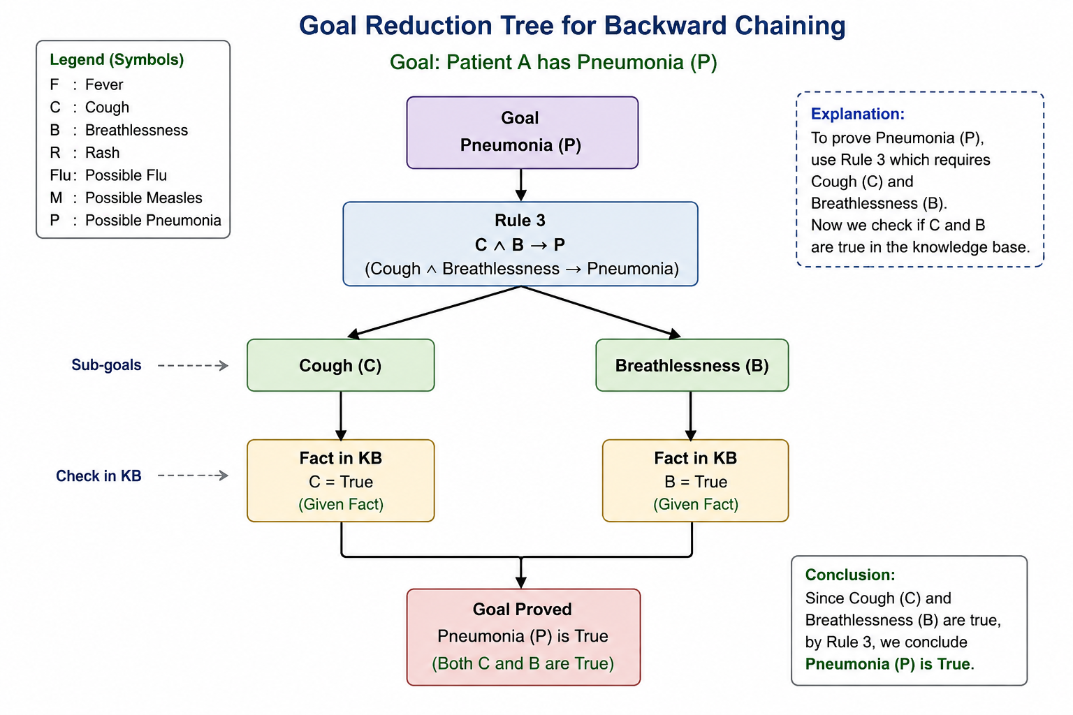
Final Conclusion
Since Cough and Breathlessness are both facts in the knowledge base, Rule 3 can be applied. Hence: The goal is successfully proved by Backward Chaining.
Case Study 2 — Autonomous Traffic Management Agent
(a) Unification
Rule 1
∀x[Vehicle(x)∧EmergencyType(x)→ClearPath(x)]
Given facts:
Vehicle(Ambulance)
EmergencyType(Ambulance)
Match the variable with Ambulance:
Vehicle(x)→Vehicle(Ambulance)
Therefore:
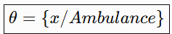
Applying the substitution:
ClearPath(x)⇒ClearPath(Ambulance)
Hence:
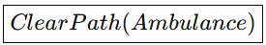
is derived.
(b) Resolution Proof of Proceed(CarA)
Convert Rules to CNF
Rule 1:
¬Vehicle(x)∨¬EmergencyType(x)∨ClearPath(x)
Rule 2:
¬ClearPath(x)∨GreenSignal(x)
Rule 3:
¬Vehicle(x)∨¬Behind(x,y)∨¬GreenSignal(y)∨Proceed(x)
To prove the goal, add its negation:
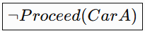
Resolution Steps
Step 1:
From Rule 1 and:
Vehicle(Ambulance), EmergencyType(Ambulance)
derive:
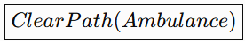
Step 2:
Using Rule 2:
ClearPath(Ambulance)
derive:
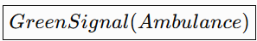
Step 3:
Using Rule 3 with:
Vehicle(CarA)
Behind(CarA,Ambulance)
GreenSignal(Ambulance)
derive:
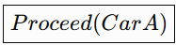
Step 4:
Resolve with the negated goal:
Proceed(CarA)
¬Proceed(CarA)
Therefore:

The empty clause proves the goal.
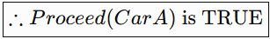
Reasoning Chain
Vehicle(Ambulance)+EmergencyType(Ambulance)
↓
ClearPath(Ambulance)
↓
GreenSignal(Ambulance)
↓
Proceed(CarA)
(c) Two Simultaneous Emergency Vehicles
The current knowledge base can identify and give signals to two emergency vehicles, but it does not handle conflicts between them.
For example, if both vehicles require the same path, the system needs additional reasoning.
Additional Rules
1. Priority Rule
Emergency(x)∧HigherPriority(x,y)→Priority(x)
2. Path Conflict Rule
SamePath(x,y)→PathConflict(x,y)
3. Waiting Rule
PathConflict(x,y)∧HigherPriority(x,y)→Hold(y)
Additional Facts
For example:
SamePath(Ambulance1,Ambulance2)
HigherPriority(Ambulance1,Ambulance2)
These allow the system to determine which vehicle should proceed first.
Conclusion
The KB needs priority, path-conflict and waiting rules for safe simultaneous routing.

CASE STUDY 3 – AGRICULTURAL EXPERT REASONING SYSTEM
(a) Convert P1, P2, P3 and Facts into CNF
Given Knowledge Base
P1: SoilDry → IrrigationNeeded
P2: IrrigationNeeded ∧ CropWheat → ApplyDripMethod
P3: ¬ApplyDripMethod ∧ CropWheat → CropAtRisk
Facts:
SoilDry = True
CropWheat = True
P1: SoilDry → IrrigationNeeded
Step 1: Eliminate implication.
SoilDry → IrrigationNeeded
becomes:
¬SoilDry ∨ IrrigationNeeded
Therefore:
P1 = (¬SoilDry ∨ IrrigationNeeded)
P2: IrrigationNeeded ∧ CropWheat → ApplyDripMethod
Step 1: Eliminate implication.
¬(IrrigationNeeded ∧ CropWheat) ∨ ApplyDripMethod
Step 2: Apply De Morgan's law.
¬IrrigationNeeded ∨ ¬CropWheat ∨ ApplyDripMethod
Therefore:
P2 = (¬IrrigationNeeded ∨ ¬CropWheat ∨ ApplyDripMethod)
P3: ¬ApplyDripMethod ∧ CropWheat → CropAtRisk
Step 1: Eliminate implication.
¬(¬ApplyDripMethod ∧ CropWheat) ∨ CropAtRisk
Step 2: Apply De Morgan's law.
ApplyDripMethod ∨ ¬CropWheat ∨ CropAtRisk
Therefore:
P3 = (ApplyDripMethod ∨ ¬CropWheat ∨ CropAtRisk)
Facts in CNF
SoilDry = True:
SoilDry
CropWheat = True:
CropWheat
Final CNF Knowledge Base
- ¬SoilDry ∨ IrrigationNeeded
- ¬IrrigationNeeded ∨ ¬CropWheat ∨ ApplyDripMethod
- ApplyDripMethod ∨ ¬CropWheat ∨ CropAtRisk
- SoilDry
- CropWheat
(b) Resolution Refutation to Prove ApplyDripMethod
Step 1: State the Goal
Goal:
ApplyDripMethod
For Resolution Refutation, negate the goal:
¬ApplyDripMethod
Add it to the knowledge base.
Now we have:
- ¬ApplyDripMethod
Step 2: Derive IrrigationNeeded
Use:
- ¬SoilDry ∨ IrrigationNeeded
and:
- SoilDry
Resolving them gives:
IrrigationNeeded
Step 3: Derive ApplyDripMethod
Use:
- ¬IrrigationNeeded ∨ ¬CropWheat ∨ ApplyDripMethod
We have:
IrrigationNeeded
and:
CropWheat
Therefore:
ApplyDripMethod
Step 4: Derive the Empty Clause
We have:
ApplyDripMethod
and the negated goal:
¬ApplyDripMethod
Resolving them gives:
□
The empty clause means a contradiction has been obtained.
Therefore, the negated goal is false.
Hence:
ApplyDripMethod is TRUE.
Resolution Proof Summary
- SoilDry
- ¬SoilDry ∨ IrrigationNeeded
- IrrigationNeeded
- CropWheat
- ¬IrrigationNeeded ∨ ¬CropWheat ∨ ApplyDripMethod
- ApplyDripMethod
- ¬ApplyDripMethod
- □
Therefore:
The theorem ApplyDripMethod is proved.
(c) Remove SoilDry from the Knowledge Base
Suppose the fact:
SoilDry
is removed.
The remaining fact is:
CropWheat = True
Step 1: Check P1
P1 is:
SoilDry → IrrigationNeeded
But SoilDry is no longer available.
Therefore:
IrrigationNeeded cannot be derived.
Step 2: Check P2
P2 is:
IrrigationNeeded ∧ CropWheat → ApplyDripMethod
Although:
CropWheat = True
we do not know:
IrrigationNeeded = True
Therefore:
ApplyDripMethod cannot be derived.
Step 3: Check P3
P3 is:
¬ApplyDripMethod ∧ CropWheat → CropAtRisk
We know:
CropWheat = True
But we do not know:
¬ApplyDripMethod = True
Therefore:
CropAtRisk cannot be derived.
Final Analysis
After removing SoilDry:
IrrigationNeeded = Cannot be derived
ApplyDripMethod = Cannot be derived
CropAtRisk = Cannot be derived
Important Logical Point
Not being able to prove ApplyDripMethod does NOT mean that:
¬ApplyDripMethod
is true.
Therefore, CropAtRisk also cannot be concluded.
Final Conclusion
The fact SoilDry is essential because it allows the system to derive IrrigationNeeded. This leads to ApplyDripMethod through P2. When SoilDry is removed, the reasoning chain stops at P1. Therefore, neither ApplyDripMethod nor CropAtRisk can be logically concluded.
Final Result:
SoilDry → IrrigationNeeded → ApplyDripMethod
Without SoilDry:
IrrigationNeeded → Not Proved
ApplyDripMethod → Not Proved
CropAtRisk → Not Proved

CASE STUDY 4 – WUMPUS WORLD KNOWLEDGE AGENT
The agent perceives:
- Stench at [1,2]
- Breeze at [1,1]
- Glitter at [2,2]
Given Rules
- Stench[1,2] → Wumpus is adjacent to [1,2]
- Breeze[1,1] → Pit is adjacent to [1,1]
- Glitter[x,y] → Gold is at [x,y]
- ¬Wumpus[x,y] ∧ ¬Pit[x,y] → Safe[x,y]
(a) Construct the Belief State and Apply Modus Ponens
Initial Percepts
The agent observes:
Stench[1,2] = True
Breeze[1,1] = True
Glitter[2,2] = True
These observations are added to the knowledge base.
Step 1: Apply Rule 1
Rule 1:
Stench[1,2] → Wumpus is adjacent to [1,2]
Given:
Stench[1,2] = True
By Modus Ponens:
Wumpus is adjacent to [1,2]
The adjacent cells of [1,2] are:
[1,1], [1,3], [2,2]
Therefore, possible Wumpus locations are:
[1,1], [1,3], [2,2]
Step 2: Apply Rule 2
Rule 2:
Breeze[1,1] → Pit is adjacent to [1,1]
Given:
Breeze[1,1] = True
By Modus Ponens:
Pit is adjacent to [1,1]
The adjacent cells are:
[1,2] and [2,1]
Therefore, possible Pit locations are:
[1,2], [2,1]
Step 3: Apply Rule 3
Rule 3:
Glitter[x,y] → Gold[x,y]
Given:
Glitter[2,2] = True
Therefore:
Gold[2,2] = True
So the agent knows that the gold is at:
[2,2]
Step 4: Apply Rule 4
Rule 4:
¬Wumpus[x,y] ∧ ¬Pit[x,y] → Safe[x,y]
A cell is safe only when the agent knows that there is neither a Wumpus nor a Pit there.
From the given information, the agent does not have enough information to prove this for every cell.
Derived Knowledge
- Wumpus is adjacent to [1,2].
- Possible Wumpus locations: [1,1], [1,3], [2,2].
- Pit is adjacent to [1,1].
- Possible Pit locations: [1,2], [2,1].
- Gold is at [2,2].
- A cell can be declared Safe only when both Wumpus and Pit are known to be absent.
(b) Forward Chaining to Identify Possible Wumpus and Pit Locations
Forward Chaining begins with the given percepts and applies the rules.
Step 1: Stench
Given:
Stench[1,2]
Using Rule 1:
Stench[1,2] → Wumpus adjacent to [1,2]
Therefore:
Possible Wumpus locations:
[1,1], [1,3], [2,2]
Step 2: Breeze
Given:
Breeze[1,1]
Using Rule 2:
Breeze[1,1] → Pit adjacent to [1,1]
Therefore:
Possible Pit locations:
[1,2], [2,1]
Step 3: Glitter
Given:
Glitter[2,2]
Using Rule 3:
Glitter[2,2] → Gold[2,2]
Therefore:
Gold is at [2,2].
Final Forward Chaining Result
Wumpus may be at:
[1,1], [1,3], [2,2]
Pit may be at:
[1,2], [2,1]
Gold is definitely at:
[2,2]
(c) Safety of the Path [1,1] → [1,2] → [2,2]
The proposed path is:
[1,1] → [1,2] → [2,2]
We must check each cell using the knowledge derived above.
Cell [1,1]
There is no direct information proving that [1,1] contains a Wumpus or Pit.
However, because the Wumpus is possible at [1,1], the agent cannot guarantee that it is completely safe.
Therefore:
[1,1] = Not guaranteed safe
Cell [1,2]
From the Breeze at [1,1], we know that a Pit may be adjacent to [1,1].
[1,2] is one of those possible Pit locations.
Therefore:
[1,2] may contain a Pit.
Also, [1,2] itself has a Stench, indicating a Wumpus is adjacent to it.
Therefore, [1,2] is not guaranteed safe.
Cell [2,2]
The agent knows:
Glitter[2,2] → Gold[2,2]
Therefore:
Gold is definitely at [2,2].
However, [2,2] is also a possible Wumpus location because it is adjacent to [1,2].
Therefore, the agent cannot guarantee that [2,2] is safe.
Final Conclusion
The path:
[1,1] → [1,2] → [2,2]
is:
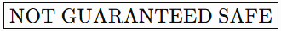
The main reason is that the available knowledge does not establish that all three cells are free from Wumpus and Pit.
The agent can confidently conclude:
- Gold is at [2,2].
- A Wumpus may be at [1,1], [1,3], or [2,2].
- A Pit may be at [1,2] or [2,1].
- Therefore, the proposed path contains cells with possible danger.
Best logical decision: The agent should not directly follow this path until additional percepts or knowledge confirm that the required cells are safe.

